Tribhuvan University

Ojashwi College

Faculty of Humanities and Social Sciences



“Project”

LAB REPORT

**Submitted To: Submitted By:**

Sambhu charan Shrestha Ram

Department of Computer Science & IT Rejina

Academia International College Roijn

Date:11th Nov, 2022

Table of Contents

Chapter 1: Introduction 3

1.1 Introduction of Proposal Project 3

1.2 Purpose and motivation 3

1.3 Vision 4

1.4 Mission 5

1.5 Objectives 5

Chapter 2: Literature Review 6

Chapter 3: Methodology 7

Chapter 4: Data Collection 8

4.1 tools 9

4.2 Project Schedule 9

Chapter 5: Conclusion 10

References 11

# Chapter 1: Introduction

## 1.1 Introduction of Proposal Project

Travel can be done by **foot, bicycle, automobile, train, boat, bus, airplane, ship or other means, with or without luggage, and can be one way or round trip**. Travel can also include relatively short stays between successive movements, as in the case of tourism. Travel is the movement of people between distant geographical locations. Travel can be done by foot, bicycle, automobile, train, boat, bus, airplane, ship or other means, with or without luggage, and can be one way or round trip. Travel can also include relatively short stays between successive movements, as in the case of tourism.

## 1.2 Purpose and motivation

Reasons for traveling include recreation, holidays, rejuvenation, tourism or vacationing, research travel, the gathering of information, visiting people, volunteer travel for charity, migration to begin life somewhere else, religious pilgrimages and mission trips, business travel ,trade, commuting, obtaining health care, waging or fleeing war, for the enjoyment of traveling, or other reasons. Travelers may use human-powered transport such as walking or bicycling; or vehicles, such as public transport, automobiles, trains, ferries, boats, cruise ships and airplanes.

Motives for travel include:

1. Pleasure
2. Relaxation
3. Discovery and exploration
4. Adventure
5. Intercultural communications
6. Taking personal time for building interpersonal relationships.
7. Avoiding stress
8. Forming memories

## 1.3 Vision

We believe that tourism should help improve the satisfaction and experience of tourist. In every way possible, Vacation & Nightlife Planners PR is committed to the realization of this vision as we strive to be recognized by organizations and travelers alike as one of Nepal s most outstanding center of tourism planning and tours. We aim to be a recognized and certified program by 2014.

In engaging this vision, the department specifically aims to:

• Encourage innovation, research, and quality information exchange within the Tourism community and among stakeholders in tourism and allied industries.

• Foster excellence in all the activities by developing appropriate physical, social and cultural environments, and by fostering a solid partnership with industry and the wider community.

## 1.4 Mission

Vacation & Nightlife Planners PR is a provider of competency-based expeditions, multi-theme activities, economical and sustainable tourism projects. In line with transformation in this sector and relevant to those who aim to pursue a budget quality experience in the tourism and allied industries. We actively seek the continual improvement of performance programs and its parts, through sharing of agglomeration of capabilities, knowledge, resources, influences and information within institutional structural and reporting arrangements.

## 1.5 Objectives

1. Provide a high standard of services suitable for individuals seeking relaxing, comfortable and memorable experiences in the hospitality and tourism industry.
2. Provide the tourist market with the quality personal required by the tourism industry.
3. Produce expeditions and memories that would satisfy each and every single of the customers.
4. Evaluate current cultural, economic, and social issues affecting the tourism and travel industry.
5. Participate in both local and regional community service by providing general lectures, consultation, and training programs.

# Chapter 2: Literature Review

For the project, we searched and review some the related websites and application throughout the research, we get to find out that there are very few websites or applications related to online jobs. So the user can’t get the qualify information and suitable job

# Chapter 3: Methodology

3.1 MoSCoW Methodology

It's based on the agile method of project management, which aims to strictly establish factors like the cost of a product, quality, and requirements as early as possible. “MoSCoW” is an acronym for must-have, should-have, could-have, and won't-have, each denoting a category of prioritization.

On the information technology (IT) side, the MoSCoW method plays an important role in Agile project management by **helping project teams prioritize story points**. Furthermore, prioritizing requirements enables project teams to understand the amount of effort and resources that will be required for each project element.

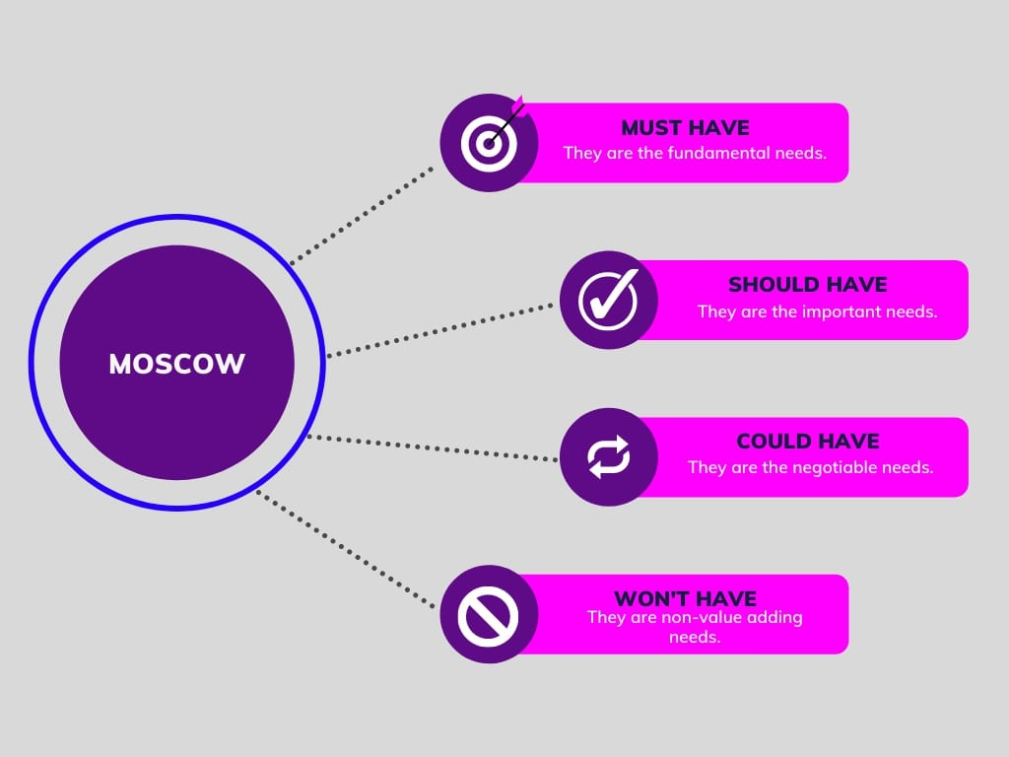

# Chapter 4: Data Collection

As our society moves away from factory jobs, lifelong education is becoming an increasing necessity. Technology and data have become a part of how we work. That change has placed more demands on educators than ever before. Whether you’re teaching in a classroom or a boardroom, you need to learn how to collect and manage data.

Although data can be valuable, too much information is unwieldy, and the wrong data is useless. The right data collection method can mean the difference between useful insights and time-wasting misdirection.

Luckily, there are several tools available for primary data collection. The methods range from traditional and simple, such as a face-to-face interview, to more sophisticated ways to collect and analyze data.

Here are the top six data collection methods:

1. Interviews
2. Questionnaires and surveys
3. Observations
4. Documents and records
5. Focus groups
6. Oral histories

## 4.1 tools

* Front end
  1. HTML
  2. CSS
  3. JAVASCRIPT

## 4.2 Project Schedule

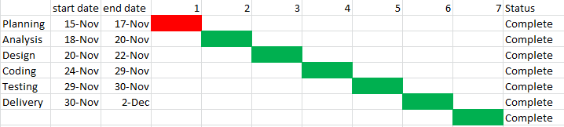

# Chapter 5: Conclusion

**Those who do get the chance, it brings excitement in their lives and teaches them new things**. No matter how a travelling experience may go, whether good or bad, it will definitely help you learn.

# References

Bibliography

Twitter. (n.d.). *getbootstrap.com*. Retrieved from Bootstrap: https://getbootstrap.com/